Lab – Module 3

Shaun Pritchard

Rasmussen College

CDA3315C

Alan Dennis

July,23 2020

Lab – Module 3

**Module-1** – completed full project scope and all specification of the assigned enterprise architecture web application.

**Full web application and its updates can be found here:**

<https://enterprisearchitecturewebapp.azurewebsites.net>

**Module 2 -** In this lab I updated the interface to pull out the active database tables and display them in the web application. I also added a new column to display the current database table that all the submissions are stored in, and I added a delete function to unregister a user. See screenshots below in *Lab Module 2 section.*

**Module-3** - In this lab I have updated the database CRUD functionality and to create a READ function that displays all the active database inventory through an alert action display popup to view current submissions. I am also working on the logic to show the users data who have been deleted from the inventory registry as well. Shown below in **Fig:3-1**.

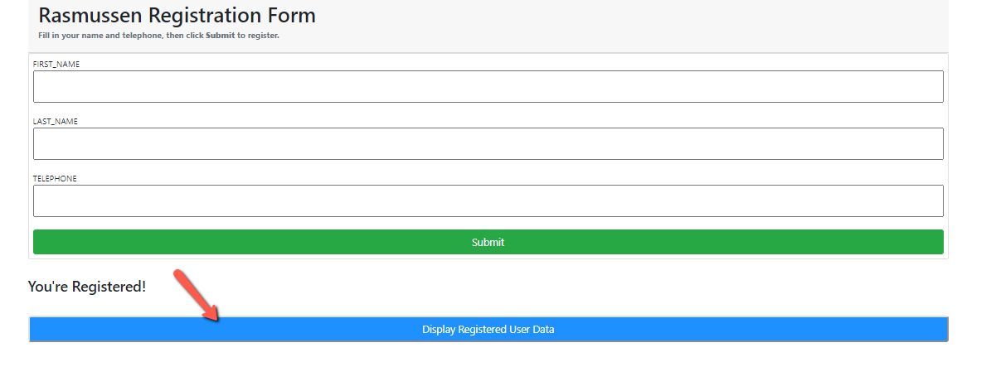 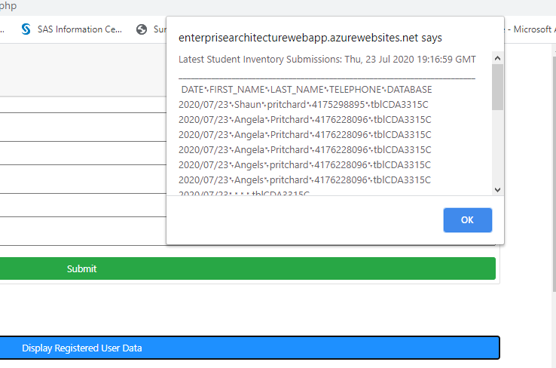

**Fig:3-1:** Added READ functionality and alert to display invintory data on click event.

**Lab- Module 1:**

1. **Logged in to student cloud portal system.**

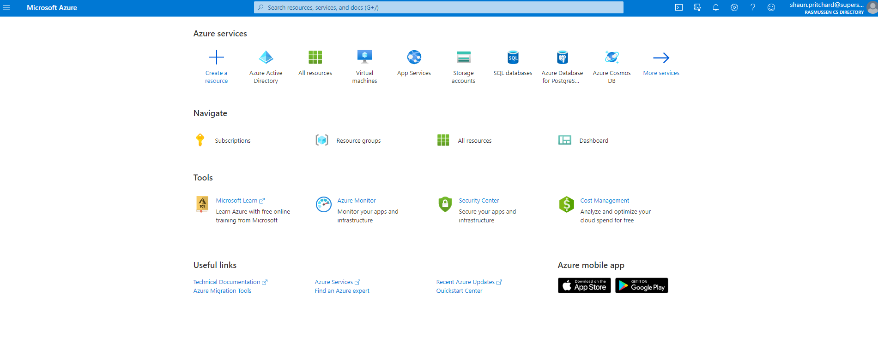

1. **Created a new Web App + MySQL service on Azure.**

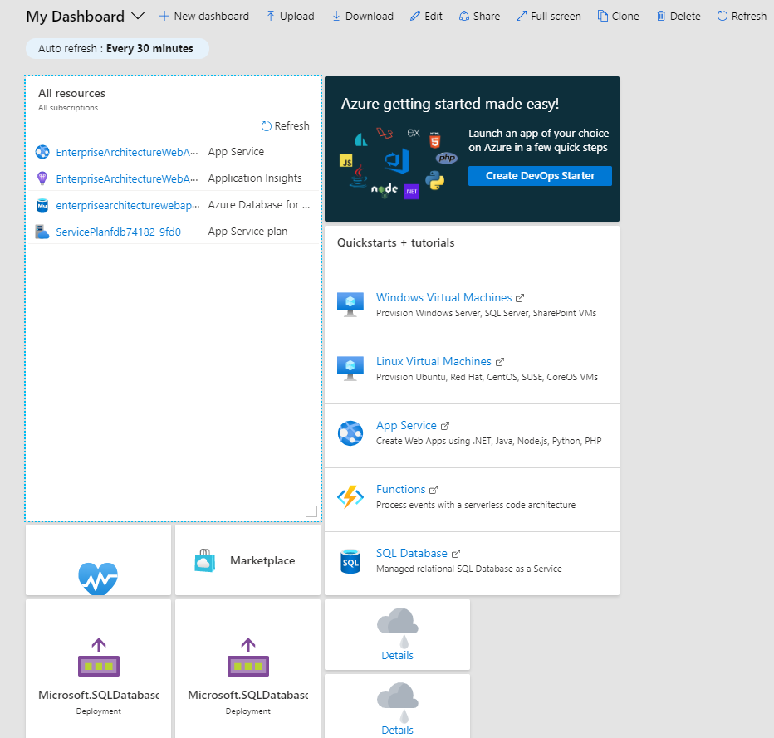

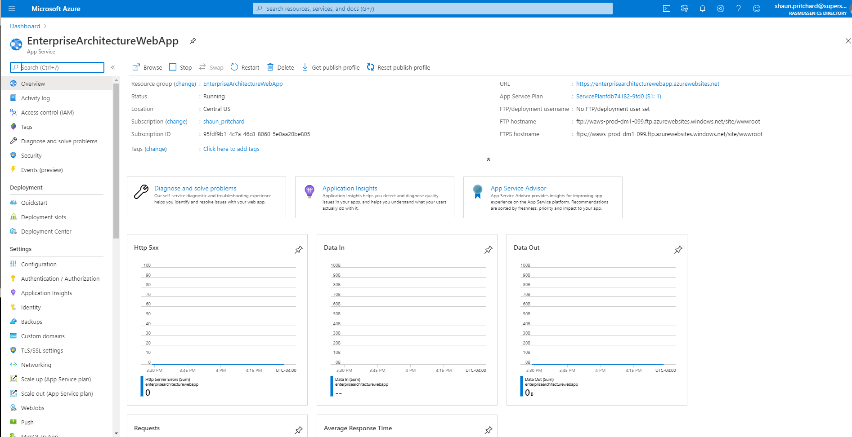

1. **Create a new MySQL database service.**

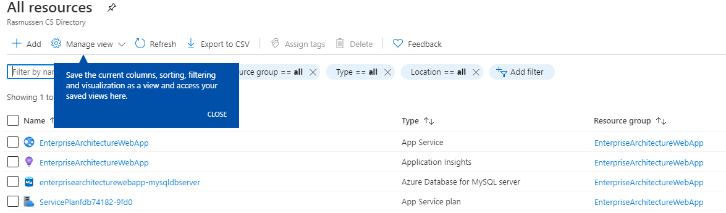

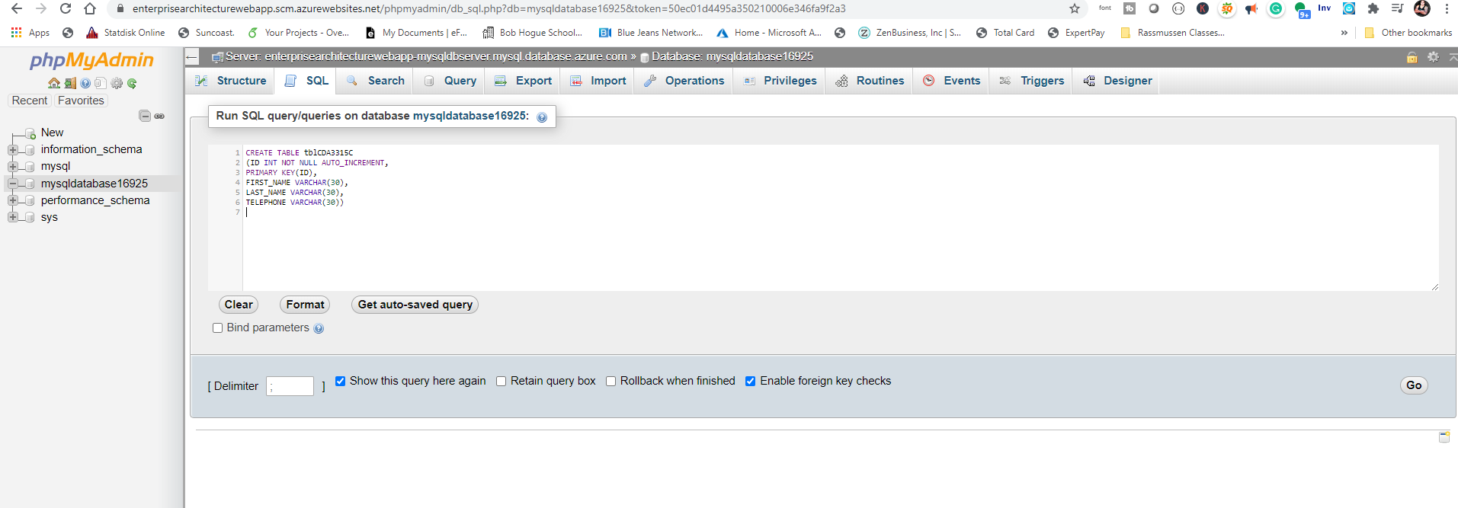

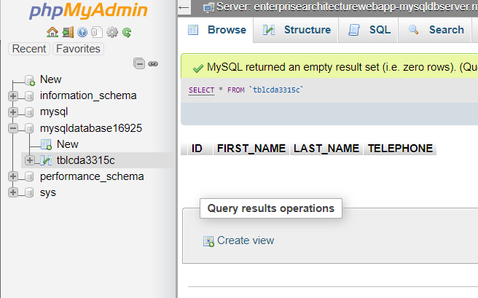

1. **Create a new Web App service connection string.**

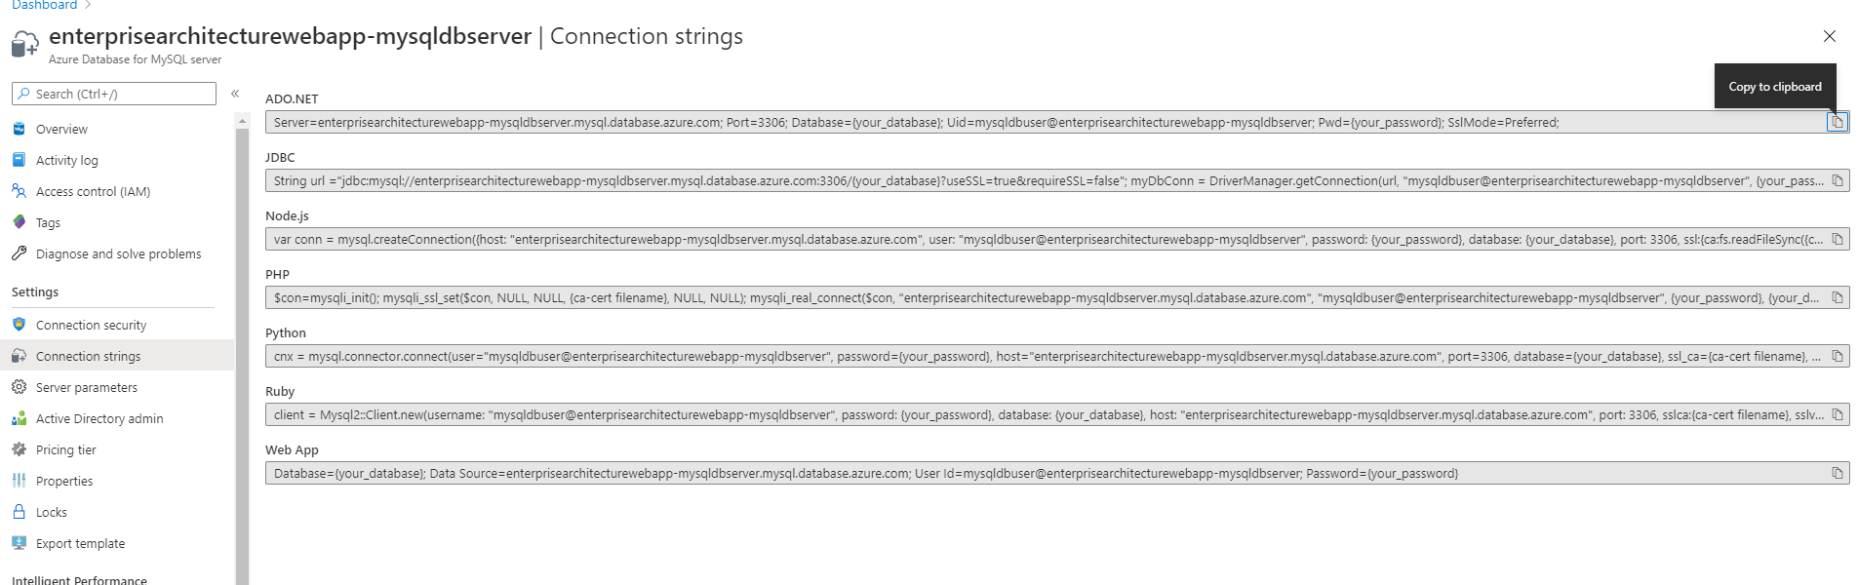

1. **Create a new Web App service phpMyAdmin extension.**

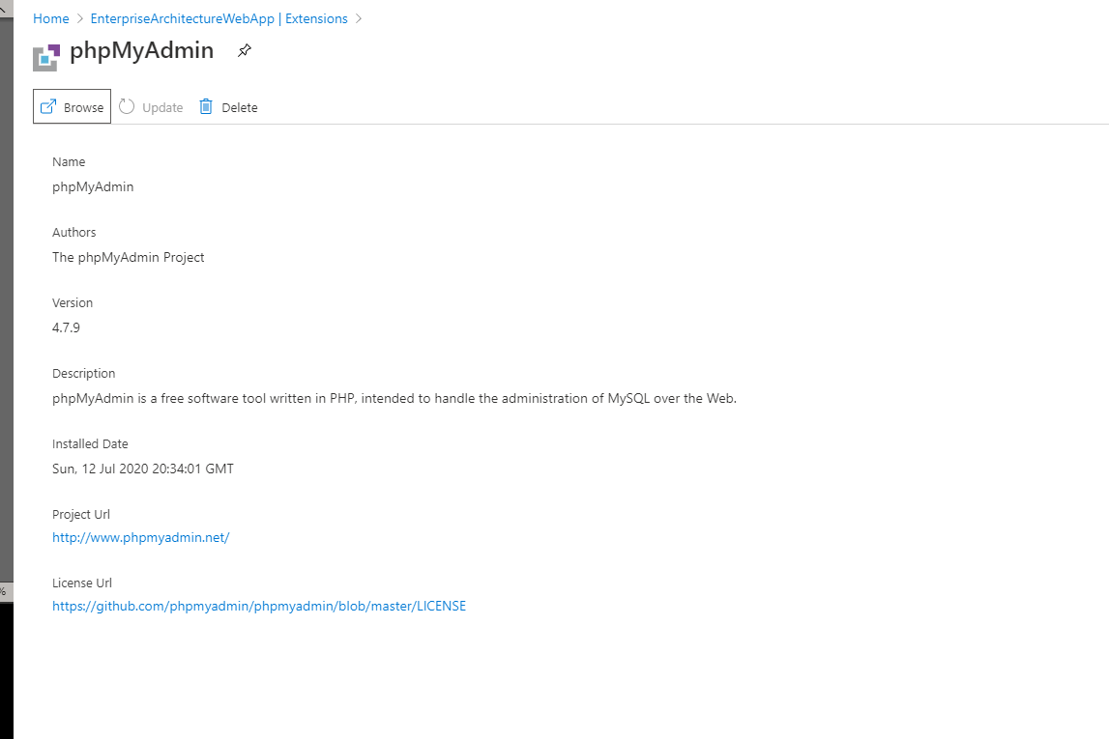

1. **Created PHP service and launched PHP my Admin**

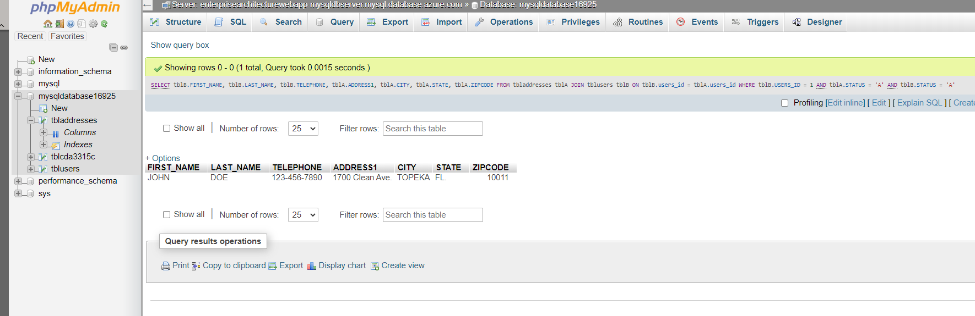

1. **Create Index.php frontend**

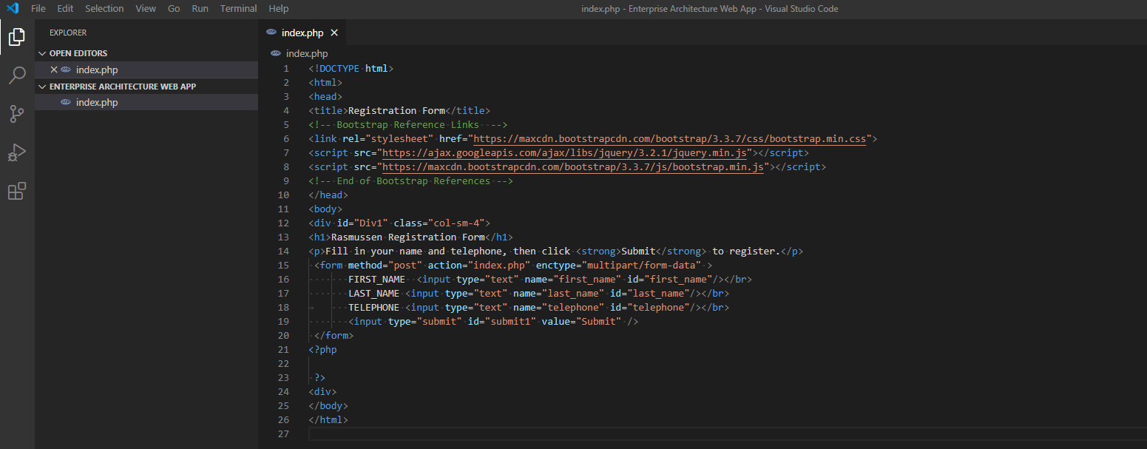

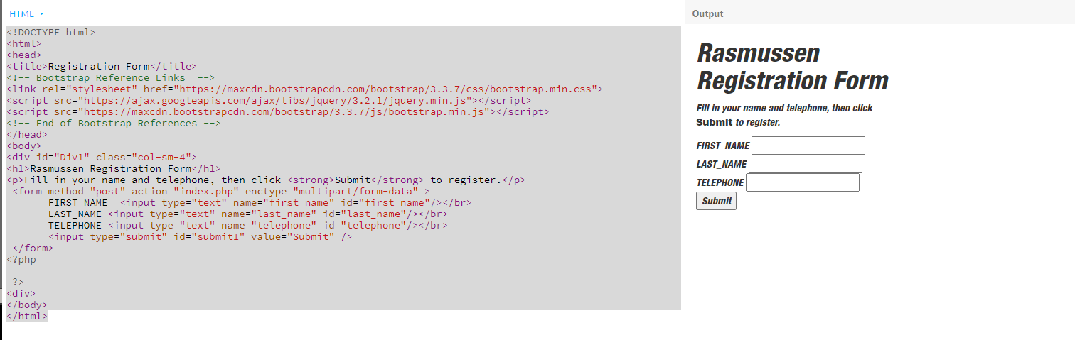

1. **Login to the new phpMyAdmin web app.**

**I had some issues with the inline CSS, so I had to repair it to the best of my knowledge using bootstrap and raw CSS It is responsive now see below.**

**Issues from CSS:**

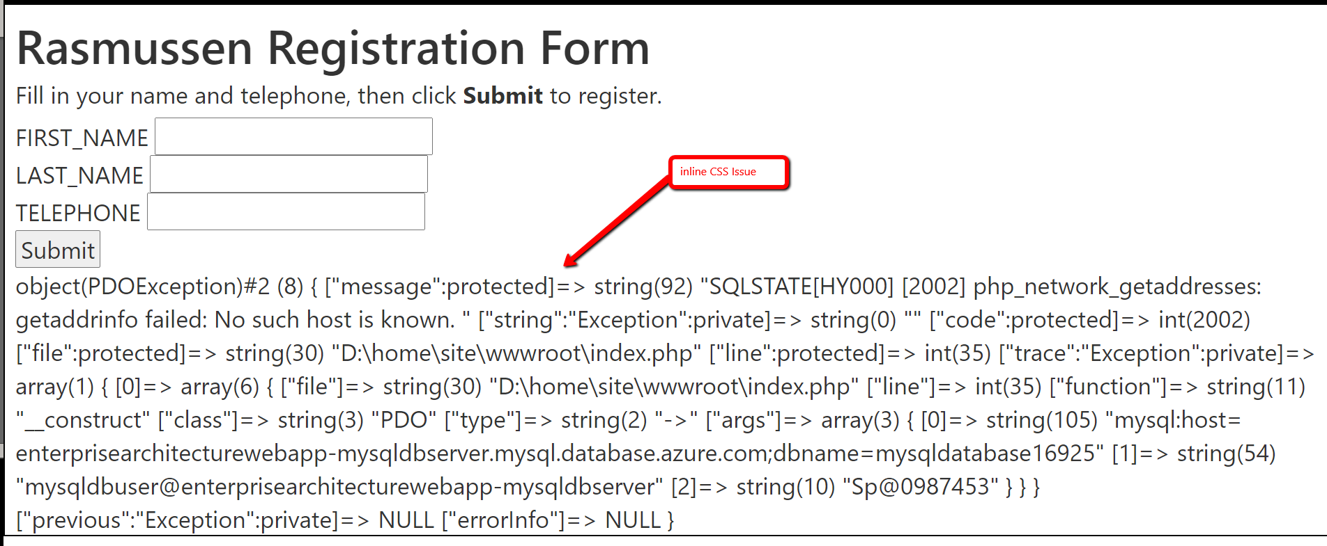

1. **Using FTP to load finished Web App:**

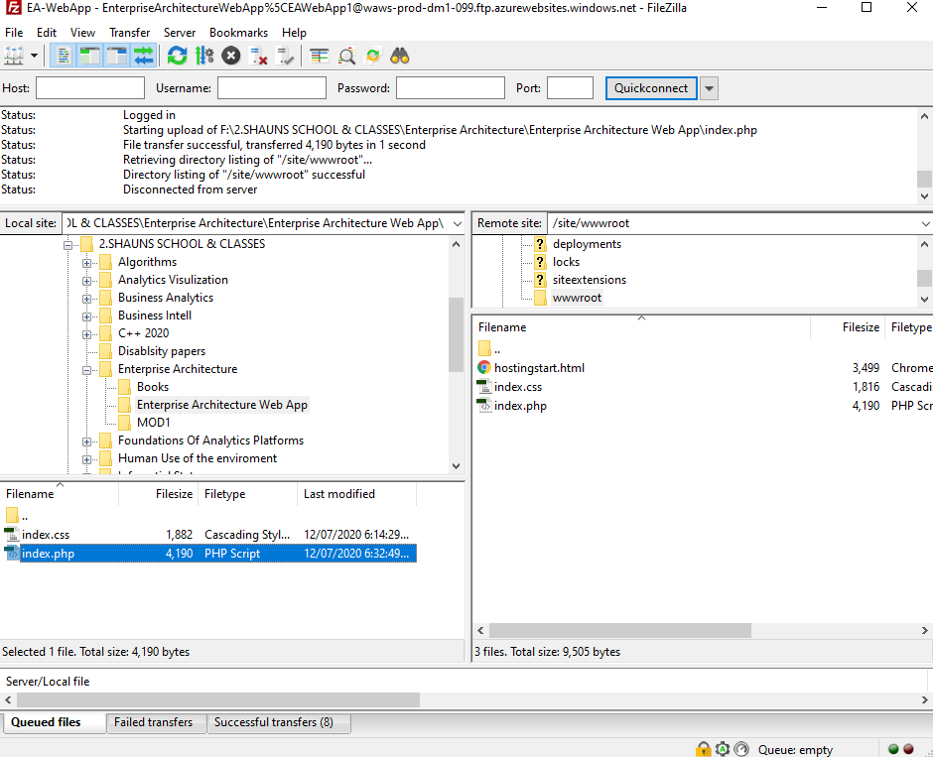

**10.Finished responsive Web App with 6 submit to DB styled by me:**

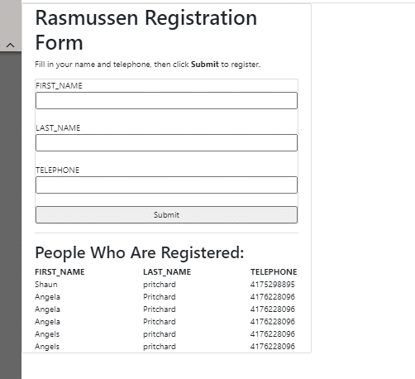

1. **Responsive version**

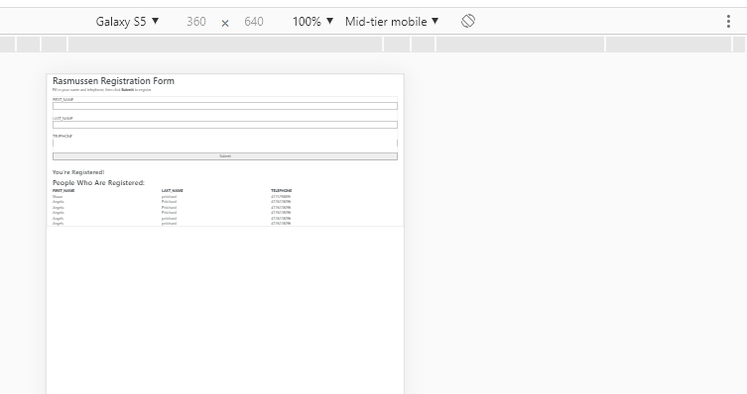

1. Here is with the original inline CSS style. It did not seem to scale correctly.

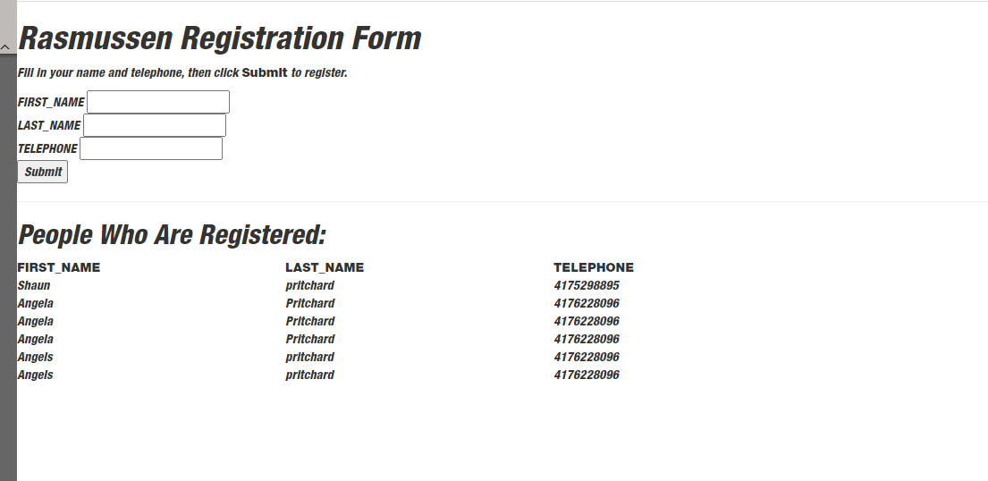

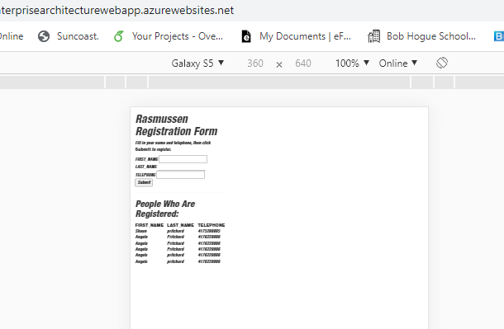

**Finished…**

**Lab- Module 2:**

1. **Updated style of user registration form centered column and made fully mobile responsive.**

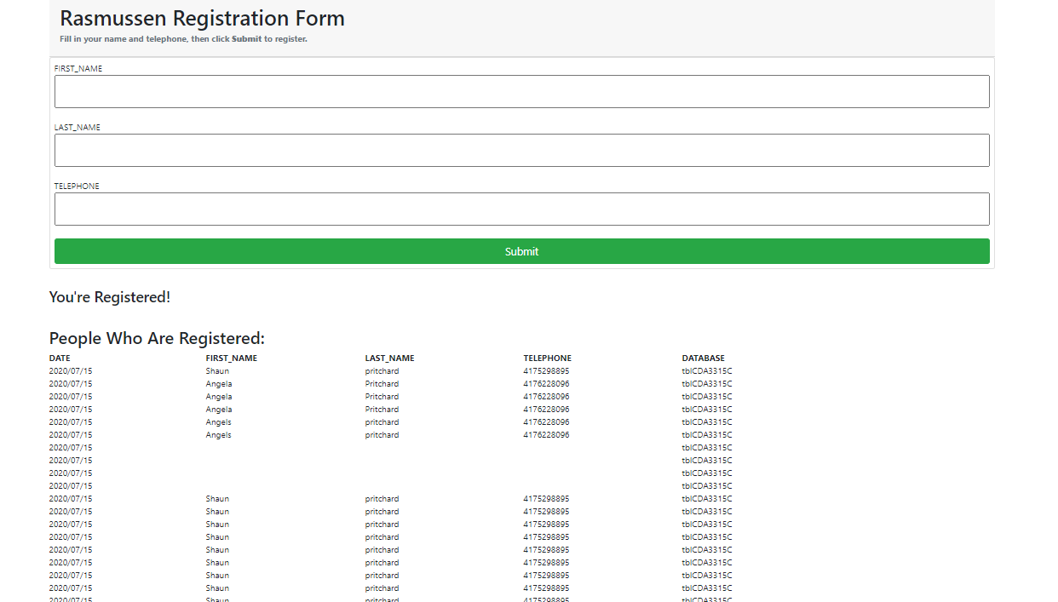

1. **Added 5th column to display the database table name of saved registered users**



1. **Added functionality to pull out all database table names programmatically using PHP and display them in the web Application.**

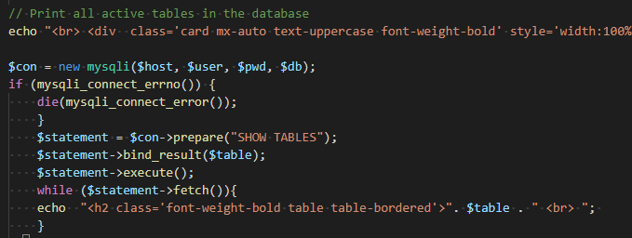

1. **Added delete functionality to remove a user row from the submission list.**

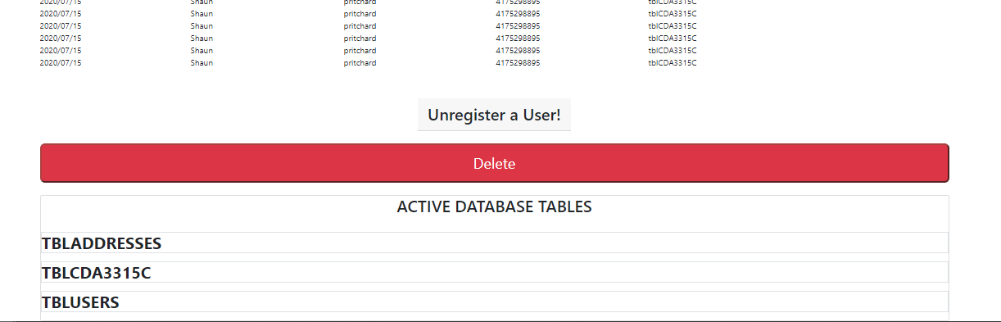

1. **Can delete users from submission list.**

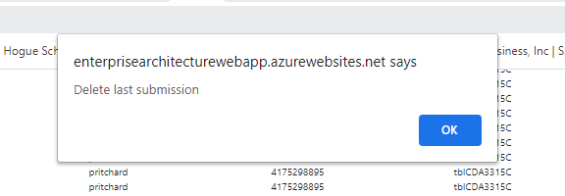

**Record with user Shaun:**



**Removed record of user Shaun:**



1. **Is mobile responsive and improved**

